BUOYANCY & FLOATATION

EB&FCC09A. A metallic cube 30 cm side and weighing 450 N is lowered into a tank containing a two fluid layer of water and mercury. Top edge of the cube is at water surface. Determine the position of block at water mercury interface when it has reached equilibrium

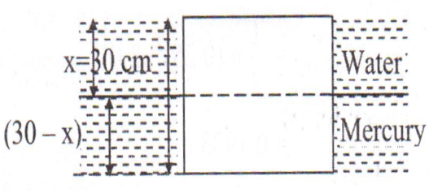

EB&FMC03A. A ship is sailing in the ocean the captain of the ship observes an iceberg floating in the sea at a distance and he estimates the visible volume of the iceberg above sea level as 600 m³. If the density of the iceberg is 915 kg/m³, determine the total volume and weight of the iceberg. The density of the sea water may be taken as 1025 kg/m³

EB&FMC97A. A rectangular container having base area of 1.5 m² and length 0.9 m is floating in water with the open end downwards. If the difference in water levels inside and outside the container is 10 cm,
i) Determine the mass to the container
ii) What force will be required to depress the bottom of the container to a depth of 10 m in water if the trapped air has constant temperature?
Atmospheric pressure = 100 KPa
EB&FMC04A. A hollow cylinder of 1 m long has an internal diameter and external diameter equal to 0.4 and 0.6 m, respectively and both ends are open. Assuming the weight of the cylinder as 700 N, analyze whether the cylinder would be stable while floating in water with its axis vertical.
EB&FMC07A. Determine the position in which a solid cylindrical block of wood of diameter 0.3 m and length 0.4 m will float in water. Take specify gravity of wood as 0.5.
EB&FMC11A. A solid, half cylinder shaped log of 0.48 M radius and 2.5 m long floats in water with the flat face up. If the immersion depth of the lowest point is 0.3 m, what is the uniform specific weight of the log?

