HYDROSTATIC FORCES

EHSFCC10A. Determine the total pressure on a plane rectangular plate 1 m wide and 3m deep when its upper edge is horizontal and coincides with water surface and plate is held perpendicular to water surface.

EHSFCC98B. A vertical lift gate 5m × 2.5 m size weighing 0.5 tonnes slides along guides (coefficient of friction 0.25) fitted on the side walls of an overflow spillway and its crest. What force will have to exerted at the hoisting mechanism to lift the gate when the head of water over the crest is 2 m?

EHSFCC11A. A 45⁰ sector gate is located on the crest of spill way. The water is up to the mid point of the gate when closed. The width of the gate is 10 m. The radius of the sector gate is 2m. Determine the hydrostatic force on the gate. Mass density 1000 kg/m³, g = 9.79 ms⁻².

EHSFCC12A. A rectangular gate of width 5 m and depth 1.5 m is installed to control the discharge as shown in figure below. The end ‘B’ is hinged. Determine the force normal to the gate applied at ‘A’ to open it.

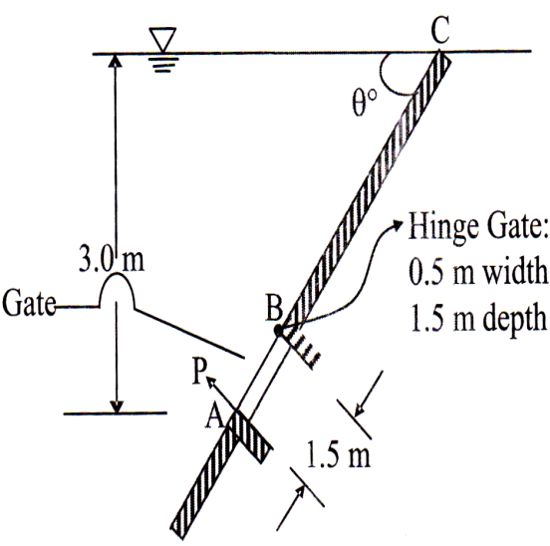

EHSFCC15A. A 9 m deep tank contains 6m of water and 3m of oil of relative density 0.88. Determine the pressure at the bottom of the tank. What is the pressure at the bottom of the tank if the entire tank is filled with water? What is the water thrust in this case? Draw the pressure distribution diagram in both the cases?

EHSFMC97A. A cubical tank has sides of 2m upto a height of 0.8 m it is filled with water and the rest space is filled with oil of specific gravity 0.85. For one vertical side calculate
i) the total pressure, and
ii) the position of the centre of pressure.
EHSFMC91A. Calculate the force F required to hold the curved gate (projected area 1 × 3m) of a reservoir as shown in figure below. [Data: I_{xx} = bh³/12 for a rectangle and centroid for a quadrant is located 2d/3π from edge.

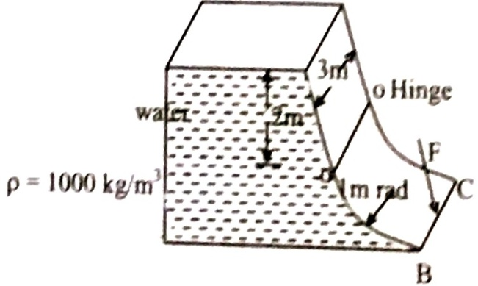

EHSFCC93A. The vertical side of a reservoir has a rectangular opening 2.75 m long and 1.2 m high. It is closed by a plate using bolts placed at the corners of the opening. What would be the tension in the bolts if water stands to a height of 1.8m above the top edge of the opening which is horizontal.

EHSFCC98A. A cylinder of radius 0.3 m in is located in water as shown. The cylinder and the wall are smooth. For a 1.5 m length of cylinder find
i) Its weight
ii) the resultant force excreted by the wall on the cylinder
iii) The resultant moment around the centre of the cylinder the water forces on the cylinder.

EHSFCC06A. Find the depth of water required to tip the rectangular flashboard reaction at the hinge of the flashboard shown in figure.
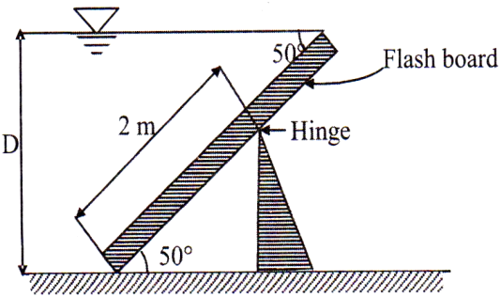

EHSFCC13A. The gates of lock are 5 cm wide by 6 m and when closed, at an angle of 120⁰. Each gate is held on by two hinges placed at the top and bottom of the gate.
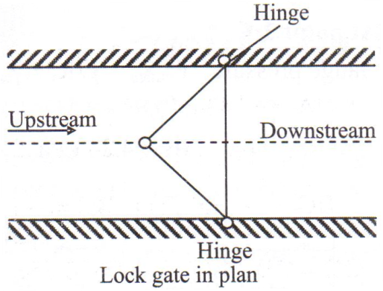
If the water levels are 6m and 4.5 m on the upstream and downstream side respectively, determine the magnitude of the forces on the hinges due to the water pressure.

EHSFMC11A. A tank with the vertical sides measuring 3m × 3m contains water to a depth of 1.2 m. An oil of density 900 kg/m³ was poured in the tank up to a depth of 0.8 m. The vertical wall can withstand the thrust of 58 kN. Calculate the actual thrust of 58 kN. Calculate the actual thrust on the wall and centre of pressure. If the oil level is increased up to 0.9 m, what will be stability of the wall?
EHSFMC12A. A water storage tank 10m × 10m × 10m has a drainage opening on one of the vertical sides at the bottom which is trapezoidal in shape with a width 2m at the bottom 4 m at the top and 1m height. A gate of same dimension hinged along the top edge is used to close it. What is the minimum horizontal force required to be applied at the bottom to keep the gate closed if the tank has full of water in it? Will there be any change in the force required if the tank is only half full? If yes how much?

