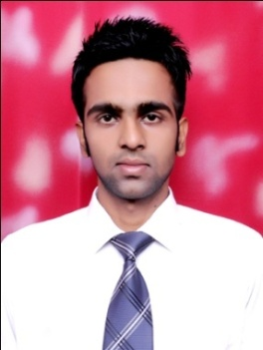**AVIKESH DAWRA**

**Email Avikesh.0123@gmail.com**

**Mobile +91-7814688628**

**OBJECTIVE**

**To use my technical and management skills so as to learn , contribute and grow with the growth of company .**

|  |  |  |  |
| --- | --- | --- | --- |
| COURSE | Board/University | Year of Passing | Percentage Secured |
| B.TECH (CIVIL) | **Punjabi University, Patiala** | **2017** | **7.68(CGPA)** |
| Intermediate (Science) | **CBSE** | **2012** | **83.40** |
| S.S.C | **CBSE** | **2010** | **8.80(CGPA)** |

**EDUCATIONAL QUALIFICATIONS**

**AREA OF INTEREST**

* **Environmental Engineering**
* **Geotechnical Engineering**
* **Hydrology and Irrigation**
* **Transportation Engineering**
* **Strength of Materials**
* **Fluid Mechanics**
* **Reinforced cement concrete**
* **Engineering Mathematics**

**ACTIVITIES AND ACHIEVEMENTS**

* **Achieved an all India rank 82 out of 129225 civil engineers in GATE-2017 examination in its first attempt.**
* **Completed a topographical survey of hilly terrain by working as a group leader of 20 students during a one week survey camp held at Chail, Shimla.**
* **Performed well in Mathematics subject with A1 grade in class 10th board exam and 97 percent marks in class 12th board exam.**
* **Actively participated in technical and literary events of theannual techno-cultural festival of Punjabi University Patiala (2013-2016).**
* **Worked as a volunteer in National Service Scheme (NSS) camp held at Punjabi University Patiala (17-23 January 2014).**

**HOBBIES**

* **Yoga**
* **Basketball**

**Personal Details**

* **Date of Birth : 6 June 1994**
* **Mother Name : Suman Dawra**
* **Father Name : Pardeep Dawra**
* **Languages Known : Hindi, Punjabi, Sanskrit, English**
* **Marital Status : Single**
* **Address : 651-Vinoba Basti**

**Sri Ganganagar (Rajasthan)**