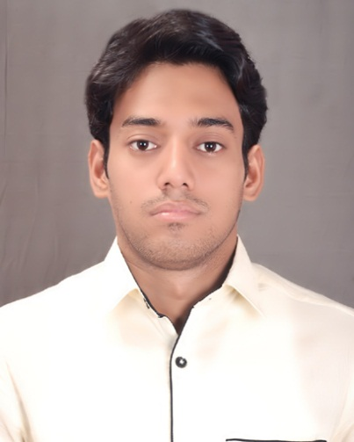**RESUME**

**TALIB KHAN**

**GATE & IES ELECTRONICS FACULTY.**

**Departments of Electronics & Communication.**

**DRONACHARYA COACHING INSTIUTE**

**FOR GATE IES &PSUs.**

**NEW DELHI INDIA**

**Contact: 09911636731 / 8603575065.**

**Email:** [**talibkhanece@gmail.com**](mailto:talibkhanece@gmail.com)

***PERSIONAL PROFILE :***

A confident enthusiastic and hardworking Electronics Faculty (GATE & IES ) who is able to teach students across the secondary age range whilst at the same time encourage them to develop their skills knowledge and confidence .Possessing extensive knowledge of contemporary teaching methods and having immense technical knowledge as well as genuine interest in educating others.

**CAREER VISION**

To work in a challenging environment demanding all my skills and efforts to explore and adapt myself in different fields and realize my potential where I get the opportunity for continuous learning.

**TEACHING ABILITIES:**

1. Able to conduct classes in a disciplined environment where students are challenged.

2. Friendly personally and excellent Communication skill

3. Maintaining good levels of behavior

4. Providing careers support and advice to pupils

**EXPERIENCE( Total 2 Yrs. ) :**

**GATE & UPSC IES Guidance at DRONACHARYA COACHING INSTIUTE DELHI [4 Oct 2014 to MARCH 2016 ]**

Role: **GATE & IES FACULTY.**

Imparting technical training on

* Electronics Devices &Ckt (EDC).
* Some Ana log Electronics Chapter.

**ALSO, I AM A FACULTY OF GK & CURRENT AFFAIRS AT DRONACHARYA COACHING INSTIUTE DELHI [Aug/14 – MARCH 2016 ]**

Role: **GK CA FACULTY FOR IES& VARIOUS PSUs.**

Imparting technical on.

* GENERAL KNOWLEDGE.
* CURRENT AFFAIRS

**EDUCATIONAL CREDENTIALS**

|  |  |  |  |  |
| --- | --- | --- | --- | --- |
| **S. No.** | **Qualification** | **Board/University** | **% of Marks** | **Division** |
| **1** | **SSC (10th)** | **JAC RANCHI** | **61** | **First** |
| **2** | **10+2 (Inter)** | **CBSE NEW DELHI** | **60** | **First** |
| **3** | **BTech(ECE)** | **PUNJAB TECHNICAL UNIVERSITY JALANDHAR** | **71.78** | **First** |
| **4** | **MTech(ECE)**  **Wireless** | **BIRLA INSTIUTE OF TECHNOLOGY BIT MESRA RANCHI** | **8.15** | **First** |

**ACHIEVEMENTS**

* Establishment of Labs of Satellite Communication (VIIth SEM) .
* I conduct practical Exam (MDU Board) as an External Examiner of subject Ana log Communication (VIIth SEM) at Dronacharya College of Engineering (Gurgaon).

**PROJECTS & DESSERTATION**

* Project work done in M.Tech. On“**DESIGN AND DEVELOPMENT OF MULTIBAND ANTENNA”.**
* Dissertation work in M.Tech. On **Design and Synthesis of 16bit Adaptive Digital Filter Architecture”.**

**WORKSHOPS/SEMINARS ATTENDED**

* Attended two days’ workshop in the “DAE Technologies for Rural India held on Feb 27-28, 2014, conducted by Global Centre for Nuclear Energy partnership, India.
* Attended two week workshop in the “Signal &System” conducted by IIT KHARAGHPUR from 2nd to 12 January 2014.
* Attended one week workshop in the “Control Systems” conducted by IIT KHARAGHPUR from 15th to 19 Sep 2013.

**Personal Details:**.

**Date of Birth:** 15th MARCH, 1988

**Hobbies:** Listening to music & Playing Chess.

**Languages Known:** English, Urdu , Punjabi and Hindi.

**References:** Available on Request.

**HOME TOWN**: DHANBAD JHARKHAND

**Marital status**: SINGLE

**PASSPORT:** Valid up to 2023.

**TALIB KHAN**