Dr. B.R Ambedkar  National Institute of Technology  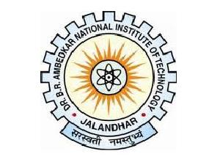  Jalandhar, Punjab | Lakshay Singla  Civil Engineering  Contact no. +91 8470071220  Email id: lakshaysingla493@gmail.com
Education:
year | degree/certificate | institute | %AGE
2011-2015 | B-Tech –Civil Engg. | NIT JALANDHAR | 70.49
2011 | 12th CLASS | Y.S PUBLIC SCHOOL | 79.80
2009 | 10th class | SANTAM DHARAM VIDYA MANDIR | 80.60

Achievements:
- Secure AIR 877 in Gate 2016 out of 1.5 lakhs candidate.
- Secure AIR 830 in Gate 2017 out of 1.5 lakhs candidate.
- Qualify the Prelims of IES ESE 2017 in 1965 students had been qualify out of 4 lakhs candidate.
- 99.8 % in AIEEE 2011 ie 18K rank out of 14 lakhs candidate.
Training and work experience:
- Work as a Graduate Training Engineer: Planning engineer in Italian Thai Development Cementation India Limited from 16 june 2015 to 20 june 2016.
Declaration:
I hereby declare that the information given above is true to best of my knowledge.
Detail and Address
Lakshay Singla, D-9 3rd floor Adarsh Nagar, Delhi-110033

