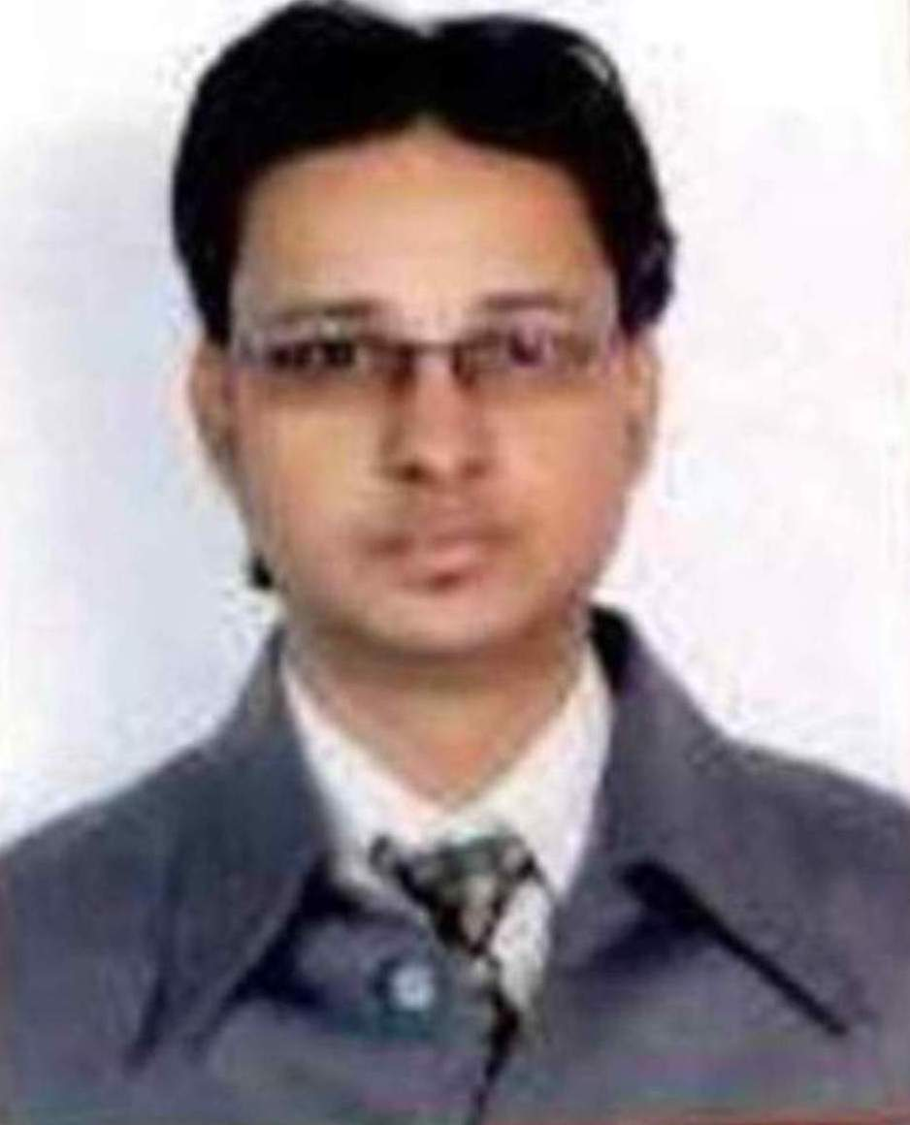
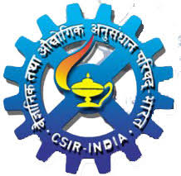
Navneet Gupta
Mobile: +91-8475086494, 8630111912
navneet.2003@gmail.com, navneet.csir@gmail.com

Objective
Seeking Responsibilities of a Guest Faculty to provide the in-depth knowledge of the concerned subjects with appropriate demonstration to the students. To guide the students about current knowledge/ Affairs concerning the subject with regular checking knowledge of the students.

Professional Qualifications

Exams | Board/University | Percentage | Year of passing
M.Tech. (IT) | IIT Bombay | 8.6 CGPA | 2010
MCA | JSSATE, Noida  Uttar Pradesh Technical University, Lucknow. | 72% | 2008
BCA | Trident College of Education,  C.C.S. University, Meerut- | 67% | 2004

Academic Qualifications
Exams | Board/University | Percentage | Year of passing
10th | CBSE Board | 86% | 1999
12th | CBSE Board | 72% | 2001

Work Experience
- Currently working in Council of Scientific and Industrial Research (CSIR), New Delhi as a Technical Assistant on “CSIR Transformation Project — ICT Interventions” ERP Project, since Nov 2011.
- 5+ Years working experience in GATE & NET Classes Coaching Centers as a Computer Science Guest Faculty during Regular Job since 2011.
- 1.4 Year working experience in Venkateshwarya Institute of Technology (VIT), Meerut as a Sr. Lecturer in Computer Science department from July 2010 to Oct 2011.

Subjects taken/ Taught
Theory Subjects:
- Operating System (OS),
- Computer Networks (CN),
- C, Data Structure (DS), Designing and Analysis of Algorithm (DAA),
- TOC + Compiler Design,

Practical Subjects:
- Data Structures with ‘C’ Language
- Visual Basic (VB 6.0),
- Java Script, HTML, CSS,
- Core java.
- Object Oriented Programming Concepts with C++
- Dot Net (ASP. Net , C#. Net) and Web Technology

Interested in teaching New Subjects
Artificial Intelligence, Neural Network and Cloud Computing etc.

Certification & Achievements
- Advance Diploma in Computer Hardware & Networking (ADCHN) from Jetking, Meerut in 2005 with 79 %.
- Diploma in Music as Indian Classical Vocal & Instrumental "Flute"
- Achieved an Outstanding Award in CSIR by the then Joint Secretary (IAS), CSIR for outstanding performance during the job career in CSIR.
- Cleared GATE in 2008, 2012, 2013, 2014 and 2015 in CS/IT Branch.
- UGC-NET Qualified in Dec-2012 for Lecturer ship.
- Got a good Rank (AIR-92) in GATE 2008 (IT),Percentile=99.99, Score=965, Marks=72.09.
- Cleared Rajasthan Public Service Commission (RPSC) State Eligibility Test (SET-2012) for Lectureship.
- Played Flute on CSIR Foundation Day in SEP-2012 in Science Center for welcoming Prime Minister of India (Dr. Manmohan Singh) and Vice-President of CSIR, Mr. Jaipal reddy.

Expertise Subjects
Theory Subjects:
Operating System, Computer Networks, Data Structures, DAA, CD.
Practical Subjects:
C language (with data structure), C++, PHP, ASP.Net, C#.net, VB.Net, Visual Basic 6.0, Java Script, HTML, CSS, core java.

Projects Description
1. CSIR Transformation Project — ICT Interventions, NOV- 2011 to July-2014
This Enterprise Resource Planning (ERP) Software Project contains six (6) vast portals namely- Human Resource (HR), Finance & Account (F&A), Research & Development (R & D), Infrastructure Engineering & Service Portal (IESP), Policy & Programme Module (PPM), And E-Learning Portal. Each Portal performs its functionality on the basis of the requirements.

2. Library Management System, August 2010 to Oct 2011.
This Software project is based on the management of Books, viz. issuing of books, returning of Books, lost of books and other books related information. The Project is developed for IIMT Engineering College, Meerut by our company in ASP.Net 2.0 as Front-end with C# and Microsoft SQL Server 2000 as Back-end.

3. Online Receipt Management System, January 2008 to July 2008.
This Software project is done during my MCA Training in CSIR- NISCAIR Lab, New Delhi. The project is based on the generation of receipt Online in ASP.Net 2.0 as Front-end with C# and Microsoft SQL Server 2000 as Back-end.

Personal Profile Summary
Father’s Name:- Late Mr. Balkishan Gupta
Mother’s Name:- Mrs. Asha Gupta
Marital Status:- Married
Spouse Name:- Mrs. Pooja Gupta
Daughter Name:- Ayesha Gupta
Son Name:- Ayansh Gupta
Siblings:- one elder brother and one elder sister
Father’s Occupation:- Retired from Bharat Sanchar Nigam Limited (BSNL)
Spouse Occupation: - Post Graduate Teacher (PGT) for Computer Science in CBSE School, Meerut.
Strengths:- Leadership, Self Motivated, Determined, Good communication skills, and Hard-working
Permanent Address: - 220/1, Swami Para, Bhudhana Gate, Meerut-city 250002 U.P. India.

Declaration
I hereby declare that the above-mentioned information is correct up to my knowledge and I bear the responsibility for the correctness of the above-mentioned particulars.

Place : New Delhi Date :

NAVNEET GUPTA

