**SHUBHAM MISHRA**

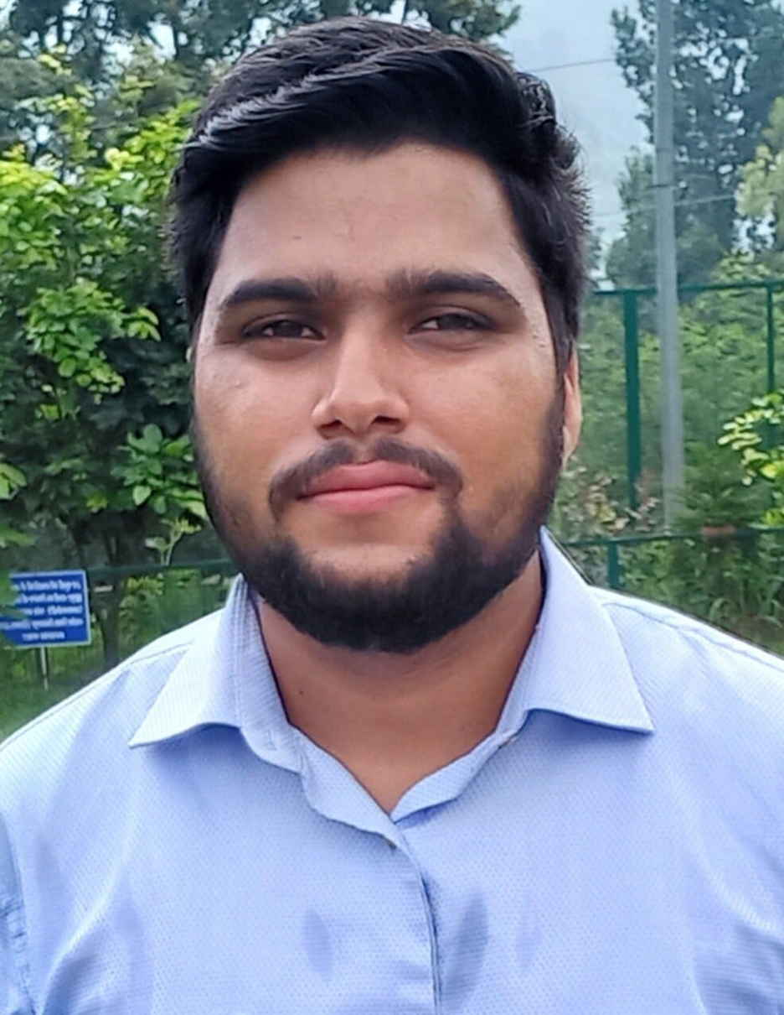

S/O Sh. Dina Nath Mishra

Village Someleta (Doon)

P.O-Rishikesh

Tehsil Jhandutta District Bilaspur (H.P)-174024

+917018985441

mishrashubham467@gmail.com

Seeking a dynamic new role as a Faculty in Civil Engineering with a view of achieving excellence by pushing my knowledge and skills towards the growth of the organization and self.

|  |  |  |  |  |  |
| --- | --- | --- | --- | --- | --- |
| **Academic Qualification:** | |  |  |  |  |
| **Qualification/Degree** | **School/College** | | **University or Board** | **Year** | **%age / CGPA** |
| M.E, Infrastructure Engineering (Highways) | Thapar Institute of Engineering and technology | | Deemed to be university | 2017-2019 | 9.30 |
| B. E.,Civil Engineering | Chitkara School of Engineering & Technology Baddi | | Chitkara University | 2012-2016 | 7.88 |
| Class XII | S.V.M Boys Senior Secondary School Bilaspur | | H.P Board | 2011-2012 | 79 |
| Class X | S.V.M Boys Senior Secondary School Bilaspur | | H.P Board | 2009-2010 | 87.14 |

|  |
| --- |
| **Research Projects:** |
| Location : CSIR- Central Road Research Institute, New Delhi  Division : Pavement Evaluation Division  Project Description : Comparison of Different Programs for Analyzing Falling Weight Deflectometer Data of a Flexible Pavement **(Dissertation)**  Duration : 1 year (July 2018 – July 2019) |
| Location : CSIR- Central Road Research Institute, New Delhi  Division : Pavement Evaluation Division  Project Description : Comparison of Various Approaches for Determination of Modulus  Values of Concrete pavement and overlay designs  Duration : 6 months (July 2018 – December 2019) |
| Location : Thapar Institute of Engineering and Technology Patiala  Project Description : Comparison of Overlay Thicknesses calculated from Benkelman Beam and  Falling Weight Deflectometer. |
| Location :CSIR- Central Road Research Institute, New Delhi  Project Description : Calibration of Bump Integrator using Dipstick. |
| Location : Chitkara University Himachal Pradesh  Project Description : Design of Engineering College (RCC Designing, Full Architectural Planning  And Structural Analysis)  Duration : 6 months |

|  |
| --- |
| **Industrial Trainings:** |
| ➢ Location : CSIR- Central Road Research Institute, New Delhi  Project Name : Functional and Structural Evaluation of the Flexible Pavement  Duration : 45 Days |
| ➢ Location : Irrigation and Public Health Department Himachal Pradesh  Project Name : Phina Singh Medium Irrigation Project  Duration : 6 months (August 2015 – January 2016) |

|  |  |  |  |
| --- | --- | --- | --- |
| **Software Skills:** | | | |
|  | * HDM-4 |  | * KGPBACK |
|  | * IITPAVE |  | * FAARFIELD |
|  | * COMFAA 30 |  | * RIVET |
|  | * Autodesk’s AutoCAD |  | * Bentley’s Staad Pro v8i |
|  | * IBM SPSS * EVERCALC |  | * Microsoft’s Office * ELMOD-6 |
|  |  |  |  |

|  |
| --- |
| **Extra-Curricular Activities:** |
| * GATE 2021 and GATE 2022 Qualified. * Selected in CSIR-Central Road Research Institute New-Delhi for 1 year internship and Dissertation work * Attended two days conference – ICOPAC (International Conference on pavement and computational approaches) held at CSIR-CRRI, New Delhi 2018 * Completed the course on ‘Geospatial Technologies for Urban Planning’ and got certified from Indian Institute of Remote Sensing * Participated in Training workshop on GIS for Civil Engineers conducted by Esri India Technologies Ltd. * Organized an event of Auto CAD named “CAD BUZZ” in Chitkara University at Techelone 2013 National level technical fest of Chitkara University. * Was member of Bentley student ambassador committee. * Attended workshop “GO GREEN” based on green buildings. * Got first position in Badminton at state level competition. * Attended INSPIRE science camp held at CSIR-IHBT Palampur (H.P) * Got Merit Certificate in 10th and 12th class. |

|  |
| --- |
| **Experience:** |
| *JULY 2018 - JULY 2019 (TRAINING AND DISSERTATION)*  Pavement design of NH projects, Pavement Evaluation of different NH/SH roads using BBD and FWD, Testing of different pavement materials.  *5 AUGUST 2019 – 30 JANUARY 2021*  Location: Shiva Institute of Engineering and Technology Chandpur, Bilaspur (H.P)  Description: Assistant Professor (Civil Engineering) |

|  |
| --- |
| **Papers Published:** |
| * “Analysis of Falling Weight Deflectometer (FWD) Data of a Flexible Pavement Using Two Different Programs”- CTRG-2019 * “Comparison of Various Approaches for Evaluation and Overlay Design of a Concrete pavement”- CTRG-2019 |

|  |  |  |  |
| --- | --- | --- | --- |
| **Personal Profile:** | | | |
| ➢ | Date of Birth | : | April 11, 1995. |
| ➢ | Sex | : | Male |
| ➢ | Marital Status | : | Unmarried |
| ➢ | Languages Known | : | English, Hindi. |
| ➢ | Hobbies | : | Travelling, Playing Badminton, Listening to music, Autocad Drafting |
|  |  |  |  |

I hereby declare that the information furnished above is true to the best of my knowledge and belief.

Place : Bilaspur (H.P)

Date : Shubham Mishra