Curriculum Vitae
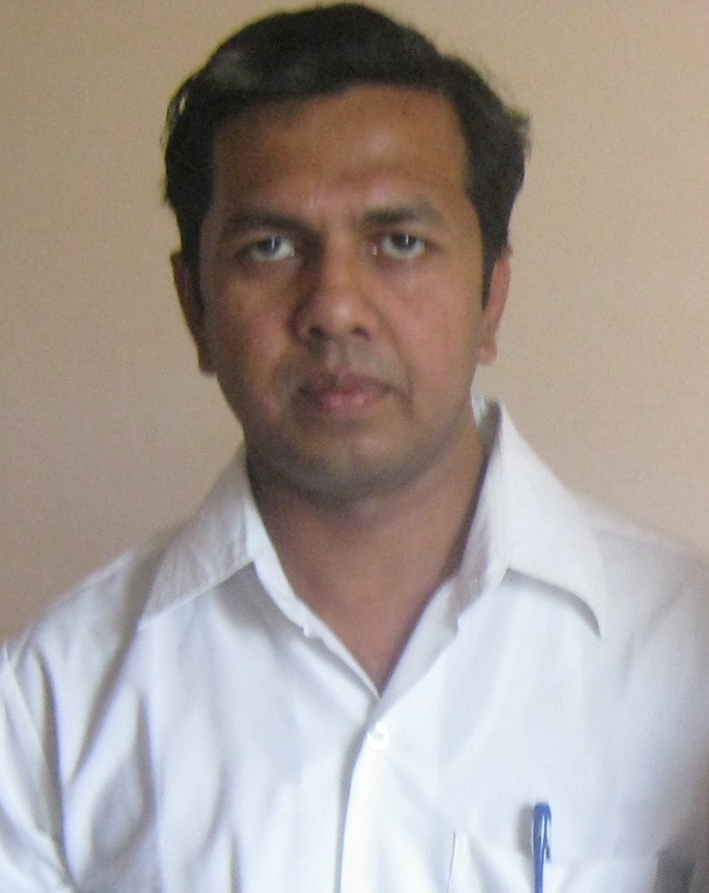
Name: Dr. Siddhartha Saha
Designation: Assistant Professor (Selection Grade)
Organization: Baba Banda Singh Bahadur Engineering College, Fatehgarh Sahib, Punjab.

Education

Ph.D PEC, University of Technology, Chandigarh
M.E. in CIM (Computer Integrated Manufacturing) with 72% marks (PEC, University of Technology, Chandigarh)
B.E. in Industrial & Production Engineering (First Class with Distinction).

Work Experience

31st July 2009 to till date Post: Assistant Professor (Selection Grade)

Presently working as Assistant Professor (Selection Grade), Baba Banda Singh Bahadur Engineering College, Fatehgarh Sahib, Punjab. My job responsibilities are:
- Teaching B. Tech and M. Tech student. (Taught different subjects like Strength of Materials, Design of Machine Elements, Mechanical Measurement and Metrology, Mechatronics, CAD/CAM, Industrial Automation and Robotics etc.).
- Organizing Faculty Development Program on CAD, ABB Robot programming, Industrial Automation using Hydraulics, Pneumatics controlled by PLC.
- Upgrading different laboratories (like Industrial Automation and Robotics)

26th April 2006 to 30th July 2009 Post: Program Coordinator

Worked as Program Coordinator for Automotive Manufacturing, Georgian College, Ontario, Canada and B.Engg, University of Brighton, UK . I was posted in Canadian Institute for International Studies (CIIS) Jalvehra, Punjab, India.
My job responsibilities were:
- To lead the Georgian College and University of Brighton B.Engg. Program in India.
- Conducting workshops for Faculty (Pro Engineer,CATIA, AutoCAD, Solidworks, PLC Allen-Bradley MicroLogix 1100, 1200 & 1500, KUKA Robot programming etc.),
- Maintaining relationship with international partners
- Teaching different subjects like Machine Design, Pro Engineer & AutoCAD, Jig Fixture and Tool Design, Automation (PLC) & Robotics, Statics, Dynamics, Strength of Materials, Engineering Materials, Fluid Mechanics etc.

2nd August 2004 to 24th April 2006 Post: Lecturer

Worked two years as Lecturer in Mechanical Engineering Department for Lovely Institute of Technology, Jalandhar which is the technology division of Lovely Professional University, Jalandhar, Punjab. Subjects taught are Theory of Machines, Engineering Drawing, Total Quality Management, CAD/CAD, and Operation Research.

Professional Workshop Organized:

- ‘Skill Development Program on Solidworks’ at Punjab Engineering College, (PEC) Chandigarh. Punjab University
- ‘Basics of Solidworks’ at BBSBEC, Fatehgarh Sahib, Punjab – conducted four times
- ‘FDP on Industrial Automation and Robotics’ at BBSBEC, Fatehgarh Sahib, Punjab
- ‘FDP on Robotics’ at BBSBEC, Fatehgarh Sahib, Punjab
- ‘FDP on AutoCad’ at CIIS, Jalvehra, Punjab.

Design Skills:

AutoCAD : 2D drafting, Solid (3D) & Surface Design
CATIA : Part Modeling, Drafting & Detailing, Assembly Modeling
Surface & Wire frame Modeling
Pro/ Engineer : Part Modeling, Drafting & Detailing, Assembly Modeling
Surface & Wire frame Modeling, CAM.
Solidworks: : Part Modeling, Drafting & Detailing, Assembly Modeling
ANSYS : Steady State Conduction, Transient Conduction
Thermal-Structural Analysis, Optimization

International Visit:

Visited Georgian College, Ontario, Barrie, Canada. Attended Faculty Development Program on International Teaching Skills. Worked closely with international education systems.

Awards and Recognition

- GATE Score: All India Rank 286 in Industrial Production Branch in the year 2002
- Was adjudged for Excellence in Service for the winter semester 2008 by CIIS.

Publications

- Saha, S., and Kalra, P, (2016), A cross-sectional survey of hand arm vibration symptoms among angle grinder operators employed in sheet metal work in North India, Int. J. of Human Factors and Ergonomics, Vol. 4, pp.112 – 125.

- Saha, S., and Kalra, P, (2016), A review on hand-arm vibration exposure and vibration transmissibility from power hand tools to hand-arm system, Int. J. of Human Factors and Ergonomics, Vol. 4, No.1, pp.10 – 46.

- Saha, S., and Kalra, P., (2015), “EMG Signal Based Muscle Fatigue Assessment – A Review”, Advances In Mechanical, Industrial & Materials Engineering, November 6-7, held at BBSBEC Fatehgarh Sahib.

- Singh, J., and Saha, S., (2015), Static analysis of alloy wheel using Ansys 15.0, International Journal of Research in Engineering and Technology, Vol 4, issue 7, pp-217-220.

- Singh, J., and Saha, S., (2015), Static structural analysis of suspension arm using FEM, International Journal of Research in Engineering and Technology, Vol 4, issue 7, pp-402-406.

- Singh, H., Singh, G., and Saha, S., (2017), “Automated Guided Vehicle System Prototype using Arduino”, International Conference On Eco-Sensitive Developments in Science & Technology (ESDST-17), January 20-21, held at BBSBEC Fatehgarh Sahib.

- Singh, J., and Saha, S., (2015), “Design And Optimization of Rod Bending Machine, Advances In Mechanical, Industrial & Materials Engineering”, November 6-7, held at BBSBEC Fatehgarh Sahib.

Contact
House No. 332, Gulmohar City, Badala Road, Kharar, Punjab
E-mail Id: ssaha.pec@gmail.com
Mob. No.9501026178

