KAMAL GARG
  Contact
  Mob :+91-9599022445
  e-mail :kamal86born@gmail.com
OBJECTIVE
To work with an organization, that would provide me opportunities to implement my learning’s optimally and help shaping my career path.

SCHOLASTICS
2011 to 2013 | Masters of Technology  “Signal Processing – Electronics & Communication”  Delhi Technological University, | 75.7%
2004 to 2008 | Bachelors of Technology  “Electronics & Communication Engineering”  ShaheedBhagat Singh State Technical Campus  (Formerly, ShaheedBhagat Singh College of Engg. &  Technology, Ferozepur, Punjab Technical University | 77.0%
2003 to 2004 | 12th - “Senior Secondary Examination”  ShaheedUdham Singh Govt CollegeSunam,  Punjab SchoolEducation Board | 73.3%
2001 to 2002 | 10th - “Matriculation Examination”  Model Basic High School Sunam,  Punjab SchoolEducation Board | 73.7%

CAREER CONTOUR
- Working as a GATE faculty for Electronics and Communication Engineering at Kreatryx, Delhi from April 2016 till date in the Communication Engineering, Signals & Systems and Engineering Mathematics subjects.
- Worked as a GATE faculty for Electronics and Communication Engineering at THE GATE Academy for the year 2015-2016.
- Working as a GATE faculty for Electronics and Communication Engineering at GATE Forum from 2013- 2015.
- Worked as GATE faculty for Electronics and Communication Engineering at Engineer’s Brain Shaper Bathinda 2012-2013.
IBM Research  Dec ‘13 to Till Date | Research Associate
Roles & Responsibilities:
- Design and Develop cloud based applications using using Python, SQL Server

Wipro Technologies LTD
Aug ’08 Till Dec ’10 Software Engineer
Roles & Responsibilities:
- Design and Develop window based application using Dot Net (C#) technology for Hewlett Packard.

INTERSHIP
HCL Technologies Ltd.
July ’07 to Dec ‘07
Project Details:
- Worked on project named “SIDEBAR” based on C# & dot NET technologies

Field of interest
- To work on ideas for “Electronification” of physicals
- Listening to Music
- Playing & Watching Cricket

Key Skills
Proficiency in a vast array of Tools, concepts and technologies that includes:
Technical Tools
VHDL Programming, Eagle CAD, Xilinx, AVR and 8051 µCs | COBOL, JCL, C/C++, C#, dot NET, MATLAB

Academic Projects & Papers
- GATE 2013 qualified having Gate score 728.
- GATE 2011 qualified having Gate score 547.
- M.Tech thesis on Security Protocol (RC4, MMIC) implemented on Wireless LAN using simulation tool as MATLAB (R2009).
- Electronic Roulette Wheel using Xilinx-XC9572 and VHDL programming Language.
- Electronic Balloon Inflation and Deflation using Xilinx-XC9572 and VHDL programming Language.
- Electronic Number Matching using Xilinx-XC9572 andVHDL programming Language.
- Electronic Race Track Panel using Xilinx-XC9572 and VHDL programming Language.
- Electronic Balloon Shooting using AVR µC (Atmega-16) and C programming Language.
- Automatic Train Engine speed control system using 8051 µC and C programming Language.
- “SIDEBAR” using dot NET, C#programming Language.
Personal Dossier
Passport Number | H0147577
Date of birth | 16 December 1986
Sex | Male
Language Known | English, Hindi, Punjabi
PermanentAddress | House No. 105, Lal Singh LaliMarg, Ward No-2, LehraGaga, Punjab-148031

PROJECTS UNDERTAKEN
PROJECT 1: ELECTRONIC ROULETTE WHEEL
Roulette is a casino game named after a French diminutive for little wheel. In the game, players may choose to place bets on either a single number or a range of numbers, the colors red or black, or whether the number is odd or even. In Electronic Roulette Wheel a number of LED’s are arranged in way similar to numbers shown on Roulette Wheel in casino each indicating a number. Then a person chooses a number from a set of available numbers. By using a push switch LED start glowing one by one in a way similar to a croupier spins the wheel and when you release the switch it continues to rotate and eventually stops at one of the position and you can compare the number chosen by the person with the number indicated by LED, if it is the same a green signal is indicated by a LED indicating the winning condition and if it does not match then that condition is indicated by glowing of red colored LED indicating the loss condition.
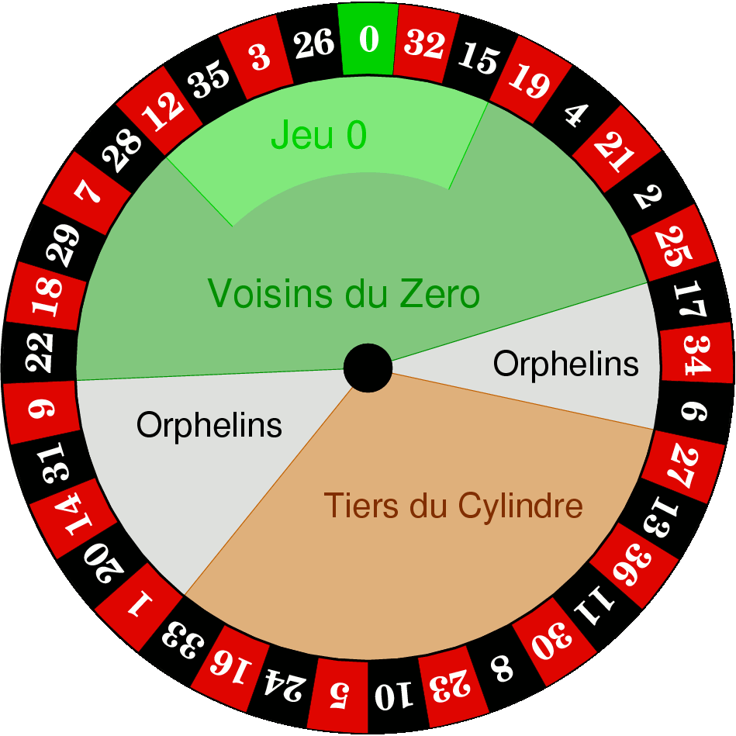  Actual Roulette Wheel | 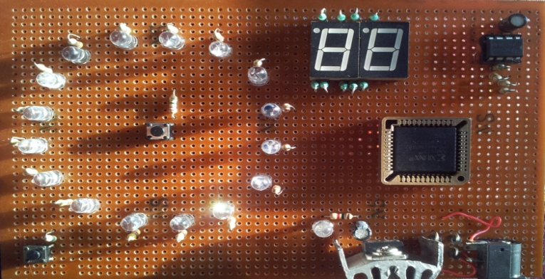  Hardware Circuit of Project
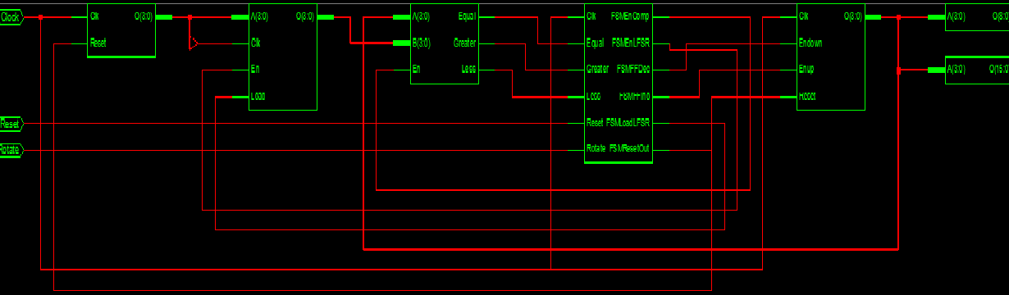
VHDL Programming Synthesis Circuit
Hardware Used
Power Supply (5V, 500mA), 555 timer circuit (1 Hz frequency), CPLD (XC-9572 Processor), LEDs, Seven Segment Displays (Common Cathode).
Software Used
Xilinx 8.2i, Eagle CAD
Programming Language
VHDL

PROJECT 2: ELECTRONIC BaLLOON INFLATING AND DEFLATING USING MOUTH
In electronic balloon inflation process, a number of LED’s are arranged in shape similar to a balloon. A temperature sensitive circuit is placed at one of the end of balloon arrangement. When someone blows air from person’s mouth to one of the end of balloon arrangement near which temperature sensitive circuit is placed, LED’s starts glowing indicating the balloon is inflating and at any point if you stop blowing air, LED’s start blowing off indicating the balloon is deflating. The arrangement also has stop button which someone can use to stop either action (inflation or deflation).
  Balloon Inflating and Deflating Mechanism | 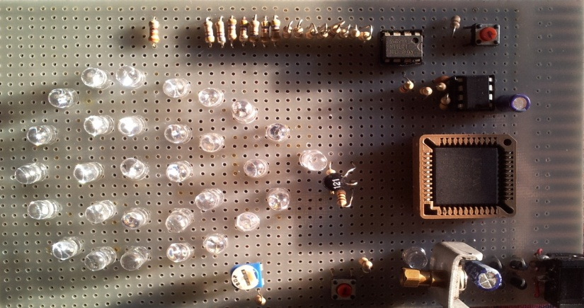  Hardware Circuit of Project
VHDL Programming Synthesis Circuit
Hardware Used
Power Supply (5V, 500mA), 555 timer circuit (1 Hz frequency), CPLD (XC-9572 Processor), LEDs, Thermistor, LM 311 Op-Amp.
Software Used
Xilinx 8.2i, Eagle CAD
Programming Language
VHDL

PROJECT 3: ELECTRONIC NUMBER MATCHING GAME
Electronic number matching game is similar to somewhat die rolling. A dieis a small throwable object with multiple resting positions, used for generating random numbers. This makes dice suitable as gambling devices for games like craps, or for use in non-gambling tabletop games. In electronic number matching game, two different displays are used. Each display shows a randomly generated number controlled by electronic switch. If a similar number is generated on both the displays it indicates the winning condition by glowing green colored LED and if it does not match it indicates loss condition by glowing red colored LED.
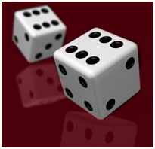  Number Display Mechanism | 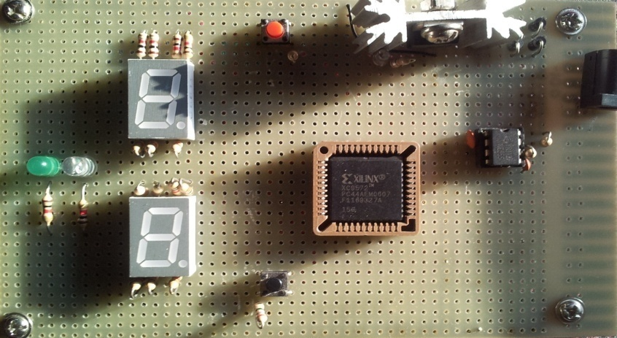  Hardware Circuit of Project
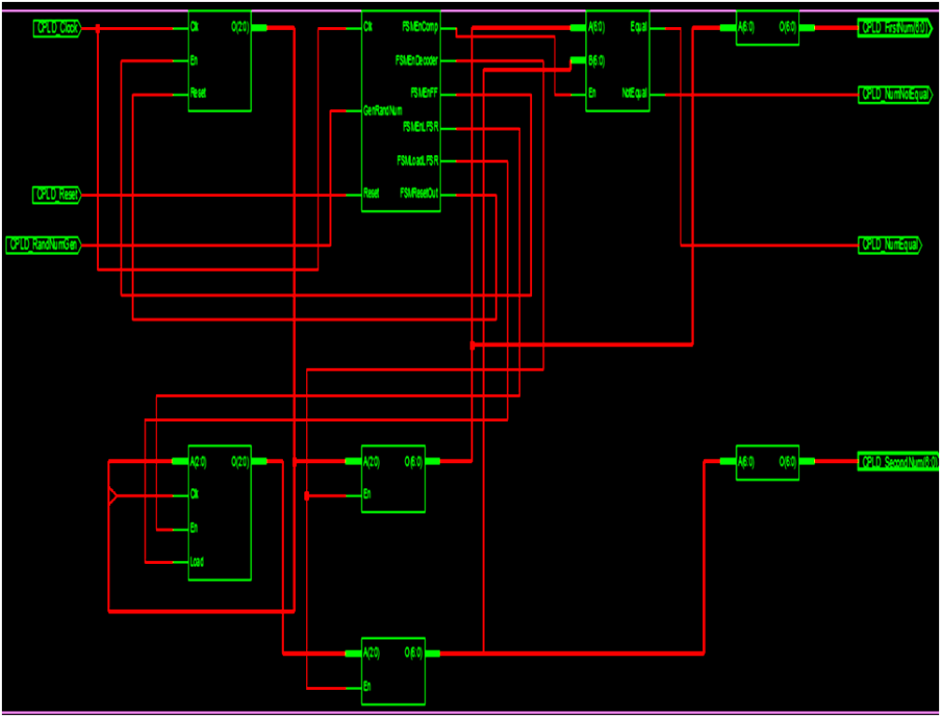
VHDL Programming Synthesis Circuit
Hardware Used
Power Supply (5V, 500mA), 555 timer circuit (48 Hz frequency), CPLD (XC-9572 Processor), LEDs, Seven Segment Displays (Common Cathode).
Software Used
Xilinx 8.2i, Eagle CAD
Programming Language
VHDL

PROJECT 4: ELECTRONIC BaLLOON SHOOTING
Electronic balloon shooting is a game that is very famous. This game is played frequently in fairs held in towns and villages. A person with the gun try to hit number of balloons on a board In electronic balloon shooting game, a number of LED’s are arranged in a fashion shown below to be treated as balloons. A Laser gun is used to shoot the balloons. As laser light from the balloon falls on a particular LED targeted that Led blow off. There are two displays used in this project one on the chip and another on the gun itself. The display on the chip indicate the number of balloons shoot out from the total number of shoot available shown on the display with the gun.
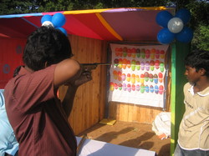  Balloon Shooting Mechanism | 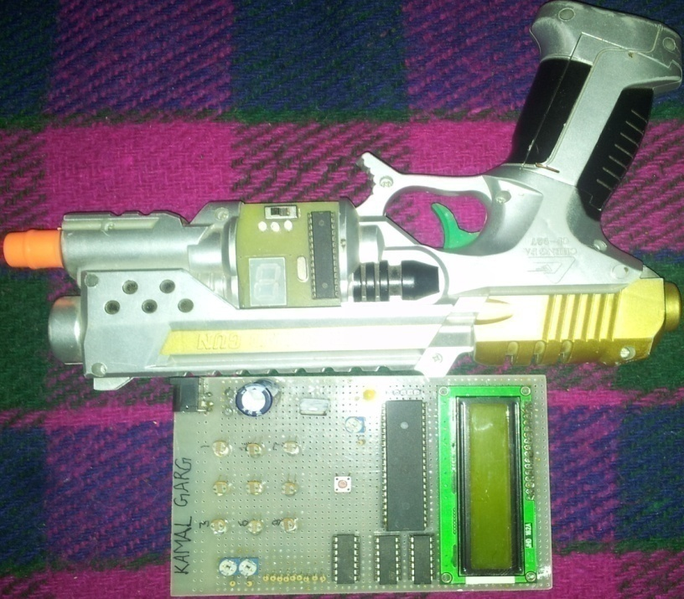  Hardware Circuit
Hardware Used
Power Supply (5V, 500mA), AVR µC (Atmega-8, Atmega-16), LEDs, LDRs, LM 311 Op-Amp, LCD(16X2) as display device, Seven Segment Display on Laser Gun.
Software Used
AVR Studio 4.0, Eagle CAD
Programming Language
C

