**Post 1**

Improve the performance of your Foton Tunland with specially designed premium quality leveling kits for Foton 4WD vehicles by Perfect Lift. Lifetime warranty of product with Australia wide free shipping. Shop online. <http://bit.ly/2dIyFhV>

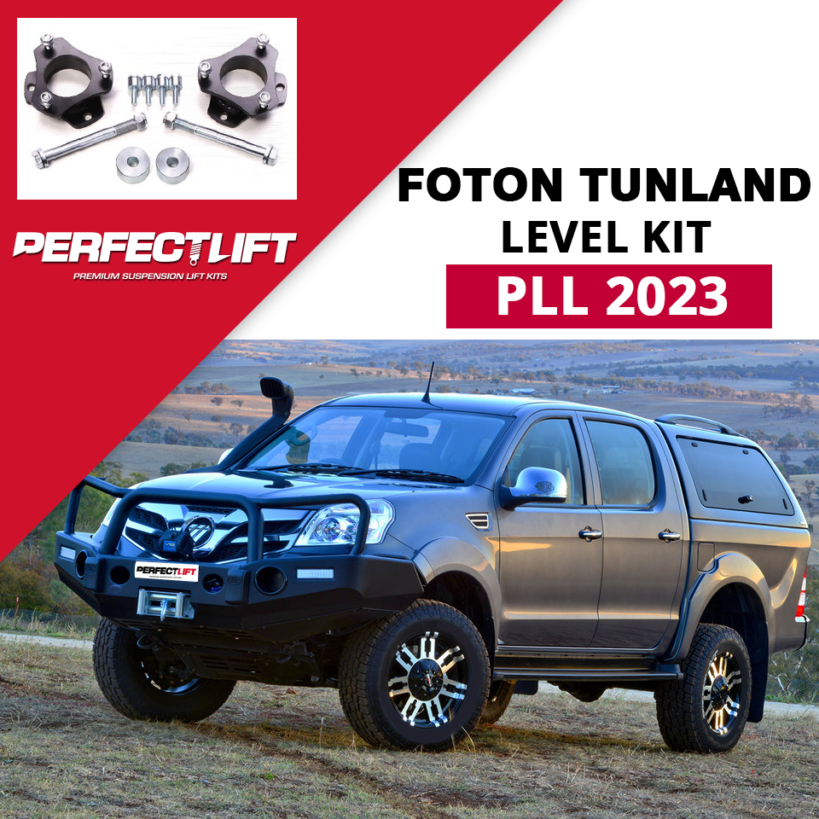

**Post 2**

Improve the ground clearance and load carrying capacity of Iszu Dumax with lift kits manufactured by Perfect Lift, a leading manufacturer and supplier of suspension lift kit products in Australia. Shop online at affordable price. <http://bit.ly/2e0yYbl>

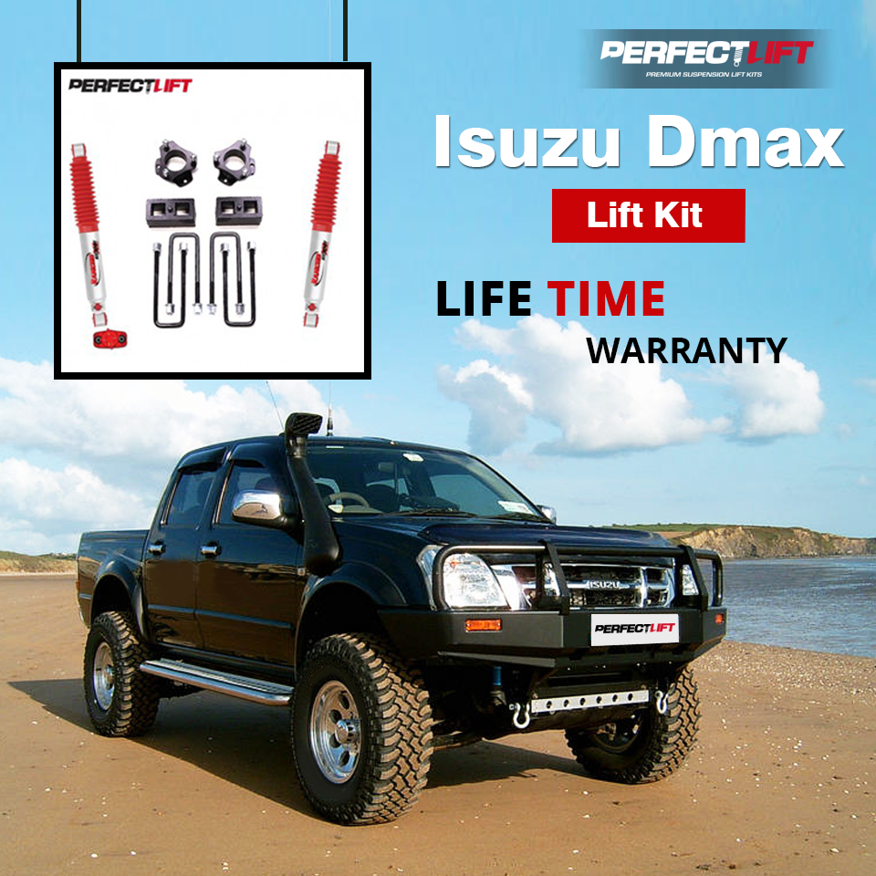

**Post 3**

Coil springs offers you smooth and comfortable ride while driving in on road/off road conditions. Shop best coil springs to suit your Mitsubishi Triton ML-MN at affordable price from Perfectlift. <http://bit.ly/2e0zk1N>

