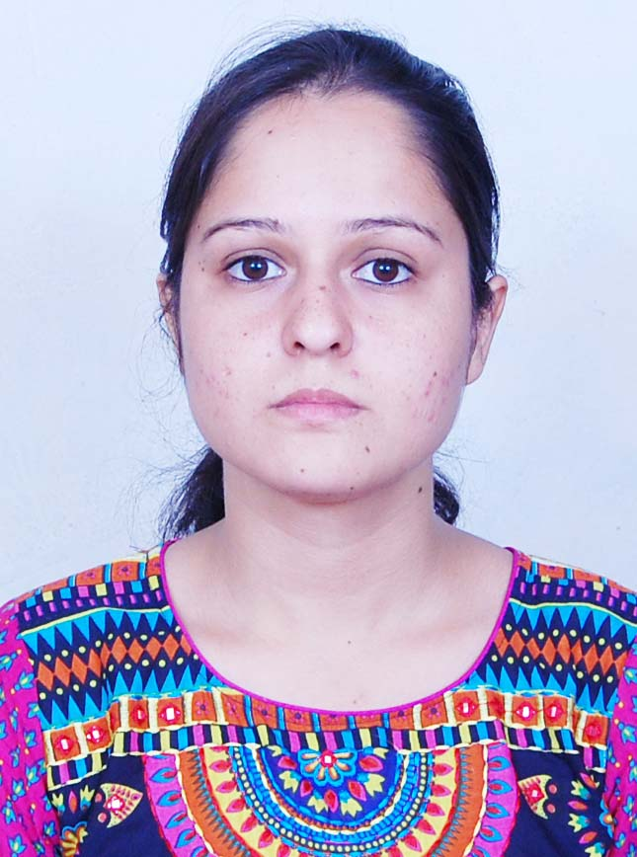

Miss BABITA
M.TECH. (ELECTRONICS AND COMMUNICATION)

Permanent Address
Vill. Manjehli, P.O. Kangoo, Teh. Naduan,
Distt. Hamirpur (H.P),
H.P (India)- 177040
Email: babitarana24@gmail.com
Mob : +918988149636, +919780526930

CAREER OBJECTIVE

- To contribute vigorously towards the growth of an organization, To serve the organization as well as nation with best of my knowledge.

ACHIEVEMENTS
SKILLS

- Gold Medalist in B.Tech. (Electronics and Communication), Himachal Pardesh University 2013.
- GATE qualified. Year-2017, Gate Score- 442. Marks- 32.42.

SKILLS SET

- Excellent knowledge of electronics subjects.
- Proficient in giving practical knowledge.

ACADEMIC QUALIFICATION

Qualification | Year | Board/University | Percentage/CGPI
M.TECH.(ECE) | 2014-2016 | Punjabi University | 8.79
B. TECH. (Honor) | 2009-2013 | Himachal Pardesh University | 82.62%
Class XII | March 2009 | CBSE | 84.60%
Class X | March 2007 | CBSE | 90%

ACADMIC PROJECTS

- B.TECH
Car Parking System based on Embedded Systems.

- M.TECH
“Performance analysis of multi-hop parallel free-space optical system over Exponentiated Weibull fading channel optimized by particle swarm optimization”
PROJECT GUIDE: Dr. Manjit Singh Bhamrah.

PUBLICATIONS

- Babita and Manjit Singh Bhamrah, "Performance analysis of multi-hop parallel free-space optical system over Exponentiated Weibull fading channel optimized by particle swarm optimization"' International Journal of Advance Research, Ideas and Innovations in Technology, vol.2, issue4, July 2016.

INDUSTRIAL TRAINING

1 month Industrial Training Embedded Systems(Eureka Electrosoft Solutions Pvt.Ltd.).

45 day Industrial Training (Web Peripherals Company Ltd).
COMPUTER PROFICIENCY

MS-Office.

Windows.

Xilinx software.

Multisim software .

MATLAB.
STRENGTH

- Confident and hardworking.
- Positive Attitude, self-motivated.
- Ability to work under stress.
- Willing to put absolute efforts to achieve goals.
- Good team player & Innovative.

PERSONAL DETAILS

- Date of Birth : 24th.March, 1992.
- Father’s name : Suram Singh.
- Languages Known : English, Hindi.
- Hobbies : Reading novels, listening Music, Cooking.
- Nationality : Indian.
- Marital Status : Single.
DECLERATION

I hereby declare that the above given information are true and to the best of my knowledge.
Date: 26-July-17 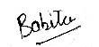
Place: HAMIRPUR BABITA

