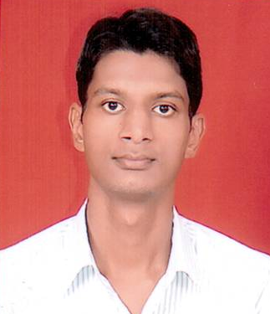
MANOJ KUMAR SAND
RESUME

ADDRESS-
C/o Jaisraj, Askaran Surana
Behind bafna clinic, Gangashahar
Bikaner-334401
E-mail : manoj.sand.ecb@gmail.com
Mobile : +91-9928145100

CAREER OBJECTIVE

My objective is to achieve perfection in my work through the process of improvement, vision combining with self-motivation and contributing to the success of organization.

WORK EXPERIENCE

- Presently working as a guest faculty in Paramount Coaching Centre Pvt. Ltd. Delhi.

- Assistant Professor in Jaipur National University, Jaipur SADTM Campus from July 2013 to May 2016.

- Lecturer in Swami Keshvanand Institute of Technology M & G, Jaipur from July 2011 to December 2012.
- Lecturer in Shankara Institute of Technology Jaipur from August 2010 to July 2011.
- Faculty in Engineering Mentor Institute, Bikaner from September 2009 to June 2010.

NATURE OF WORK

- Done teaching of undergraduate students in Electrical Engineering department in various institute.

EDUCATIONAL QUALIFICATION

- Completed B.E. in Electrical Engineering with 70.25% (Hons.) from Govt. Engineering College, Bikaner affiliated to the University of Rajasthan, Jaipur in 2009.

COMPUTER SKILLS

- Language: Basic of C, C++, Core java.

- Platform: Windows 98/2000/XP

SUBJECT SPECIALIZATION

- Electrical Measurement & Instrumentation
- Network Analysis
- Power System

EXTRA CURRICULAR ACTIVITIES

- I have attended various National and International conferences held in college.
- Participated in National conferences and Seminars held in college.
- I have worked as a team member of training and placement cell, discipline committee, proctor committee.
- Coordinated various technical and cultural events held in college.
- Attended faculty development programs to learn new teaching methodology.
- Pass the certificate ‘A’ examination of NCC and Bhartiya Sanskriti Gyan Pariksha, Haridwar at school level.

PERSONAL STRENGTH

- Maintained productive learning environment
- Effective communication skill
- Good analytic and problem solving ability
- Team spirit & optimistic by nature
- Diligent & sincerity

INTEREST & HOBBIES

- Listening Music
- Playing Badminton
- Meditation & Pranayama

PERSONAL DETAILS

- Name : Manoj Kumar Sand
- Father’s Name : Mr. Mahaveer Chand Sand
- Mother’s Name : Mrs. Saroj Devi
- Date of Birth : 16th Sept. 1986
- Sex/ Marital Status : Male / Single
- Languages Known : English, Hindi
- Nationality : Indian

DECLARATION I

I hereby declare that the above-mentioned information is correct to the best of my knowledge and I bear the responsibility for the correctness of the above-mentioned particulars.
Date:
Place: Manoj Kumar Sand

